**FLOWCHART**

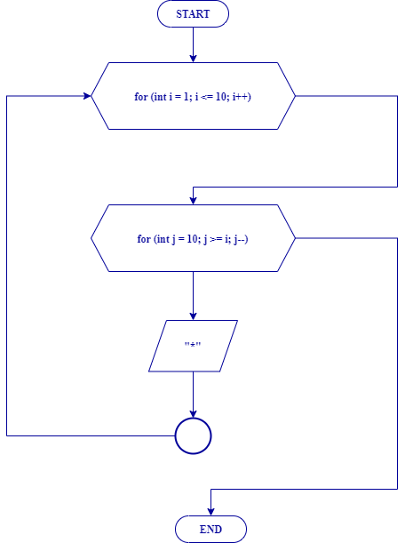

**SOURCE CODE**

**#include <iostream>**

**using namespace std;**

**int main () {**

**cout << "------------------------------------ " << endl;**

**cout << "| Looping Bintang Segitiga Terbalik |" << endl;**

**cout << "-------------------------------------" << endl;**

**cout << endl << endl;**

**for (int i = 1; i <= 10; i++) {**

**for (int j = 10; j >= i; j--){**

**cout << "*";**

**}**

**cout << endl;**

**}**

**return 0;**

**}**

**HASIL PROGRAM**

